**CHAPTER 1: INTRODUCTION**

**1.1 Overview:**

According to a report printed earlier this year by the World Health Organisation, [air pollution now kills approximately seven million people annually](https://ilmt.co/PL/EAYl), worldwide. This accounts for as much as one in eight deaths, and is by far the single major environmental health risk.

In command to counteract this shocking statistic and take action to clean up Indian air (and indeed, air around the globe), it’s significant to first understand where the pollution is most concentrated, how it occurs, what elements are involved and how we can neutralise them. In order to do this, wide-ranging air 24-hour care must be undertaken on a national and worldwide scale.

Among other pollutants, air monitors assess the amounts of carbon dioxide (CO2), carbon monoxide (CO), nitrogen oxides (NOx), ozone (O3) and particulate matter 2.5 (PM2.5). This allows us to see where and why toxic waste occurs, so that we can not only actively avoid overly polluted areas in our daily procedures but also try to device measures to curb such pollution.

**1.2. Advantages of automatic control of electric equipment’s in a home:**

Lately, remote frameworks like Wi-Fi have turned out to be increasingly regular in home systems administration. Likewise in home and building mechanization frameworks, the utilization of remote advances gives a few points of interest that couldn't be accomplished utilizing a wired system as it were

1) Reduced establishment costs: First and principal, establishment costs are altogether decreased since no cabling is essential. Wired arrangements require cabling, where material and in addition the expert laying of links (e.g. into dividers) is costly.

2) System versatility and simple augmentation: Deploying a remote system is particularly invaluable when, because of new or changed prerequisites, expansion of the system is vital. Rather than wired establishments, in which cabling expansion is monotonous. This makes remote establishments an original venture.

3) Aesthetical advantages: Apart from covering a bigger territory, this credit fulls aesthetical necessities also. Cases incorporate agent structures with all-glass engineering and recorded structures where outline or center reasons don't permit laying of links.

4) Integration of cell phones: With remote systems, partner cell phones, for example, PDAs and Smartphones with the computerization framework ends up conceivable all over the place and whenever, as a gadget's correct physical area is not any more significant for an association (as long as the gadget is in reach of the system).

For every one of these reasons, remote innovation isn't just an appealing decision in redesign and renovation, yet additionally for new establishments.

**1.3. Related Work:**

This paper proposes an Automatic framework that controls electric types of gear utilizing iot that utilizes the combination of multi-touch cell phones, remote correspondence, and electrical cable correspondence to give the client remote control of different lights and machines inside their home. This framework utilizes a union of a cell phone application, handheld remote to give a methods for UI to the purchaser.

The prime goal of this paper is to help debilitated/old matured individuals. It gives fundamental thought of how to control different home machines and give a security utilizing Android telephone/tab. The outline comprises of Android telephone with home mechanization application. Client can communicate with the android telephone and send control flag which thusly will control other installed gadgets/sensors.

The primary goal of this Paper is to outline and actualize a control and screen framework for a specific room. The brilliant house framework was upheld by remote control framework as a controlling framework. The framework additionally is associated with the web to screen and control the house gear's from anyplace on the planet.

**CHAPTER 2: LITERATURE SURVEY**

* 1. **Title of the Paper:** The Internet of Things (IoT): Applications, investments, and challenges for enterprises.

**2.1.1 INFERENCE FROM THE PAPER:**

The Internet of Things (IoT), additionally calledthe Internetof Everything or the Industrial Internet, is another innovate ion worldview imagined as a worldwide system of machines and gadgets fit for associating with each other. The IoT is perceived as a standout amongst the most imperative territories of future innovation and is picking up immense consideration from an extensive variety of ventures. The genuine estimation of the IoT for ventures can be completely acknowledged when associated gadgets can speak with each other.

**2.1.2 PROBLEM IDENTIFIED:**

It is not possible for humans to control the working of machines and equipments all the time. Also, we cannot handle or know the working of the electric equipments from any distinct place. All these problems can be overcome by using Automatic control of machines using IoT. The problems in using IoT are: Three of the main concerns that accompany the Internet of Things are the breach of privacy, over-reliance on technology, and the loss of jobs.

**2.1.3 METHODS/ METHODOLOGY:**

Five IoT advancements are generally utilized for the organization of effective IoT-based items and administrations: 1. radio recurrence distinguishing proof (RFID) 2.wireless sensor systems (WSN) 3. Middleware 4.cloud figuring and 5. IoT application programming. In view of the innovation patterns and writing survey, this article recognizes three IoT classifications for big business applications: (1) checking and control, (2) major information and business investigation, and (3) data sharing and joint effort.

**2.1.4 ADVANTAGES:**

1. Data: The increasingly the data, the less demanding it is to settle on the correct choice. 2. Tracking: The PCs keep a track both on the quality and the practicality of things at home. 3. Time: The measure of time spared in checking and the quantity of treks done generally would be huge. 4. Money: The budgetary viewpoint is the best favorable position. This innovation could supplant people who are responsible for observing and looking after provisions.

**2.1.5 LIMITATIONS:**

When anything is put on the web it will dependably be there.  Of course there are safety efforts that are taken to secure data, however there is dependably the likelihood of programmers breaking into the framework and taking the information. In any case, depending on innovation on an everyday premise, settling on choices by the data that it surrenders could prompt devastation.  No framework is powerful and blame free.

* 1. **Name of the Author/Title of the Paper:Vinay sagar K N, Kusuma S M/ Home Automation Using Internet of Things**

**2.2.1 INFERENCE FROM THE PAPER:**

Programmed frameworks are being favored over manual framework. With the quick increment in the quantity of clients of web over the previous decade has made Internet an a vital part of life, and IoT is the most recent and developing web innovation. The home robotization framework varies from other framework by enabling the client to work the framework from anyplace around the globe through web association.

**2.2.2 PROBLEM IDENTIFIED:**

Numerous current, entrenched home robotization frameworks depend on wired correspondence. This does not represent an issue until the point when the framework is arranged well ahead of time and introduced amid the physical development of the building. Be that as it may, for officially existing structures the execution cost goes high.

**2.2.3 METHODS/ METHODOLOGY:**

Computerization System can be gotten to from the web program of any nearby PC in a similar LAN utilizing server IP, or remotely from any PC or portable handheld gadget associated with the web with proper web program through server genuine IP (web IP). WiFi innovation is chosen to be the system framework that interfaces server and the sensors. WiFi is enhanced framework security (by utilizing secure WiFi association), and to expand framework versatility and adaptability.

**2.2.4 ADVANTAGES:**

Remote frameworks can be of awesome help for mechanization frameworks. With the headway of remote innovations, for example, Wi-Fi, cloud arranges in the current past, remote frameworks are utilized each day and all over the place. The framework will consequently change based on sensors' information. This framework is intended to be minimal effort and expandable enabling an assortment of gadgets to be controlled.

* 1. **Name of the Author/Title of the Paper:** Dylan sweaza/**Understanding Relays In IoT**

**2.3.1 INFERENCE FROM THE PAPER:**

Relays are basic gadgets that permit a simple path for rationale level energy to control powerful gadgets. Adding some transfers to things in your home can rapidly robotize a whole room loaded with lights and lights and convey energy to your Internet of Everything associated home.

**2.3.2 PROBLEM IDENTIFIED:**

Their parts can destroy as the switch contacts wind up filthy - high voltages and streams cause starts between the contacts. They can't be turned on and off at high speeds since they have a moderate reaction and the switch contacts will quickly destroy because of the starting. Their loops require a genuinely high current to invigorate, which implies some smaller scale electronic circuits can't drive them specifically without extra circuitry.The back-emf made when the hand-off curl turns off can harm the parts that are driving the loop.

**2.3.3 METHODS/ METHODOLOGY:**

At the point when the current is turned off, the contacts open once more, exchanging the circuit off.A useful property of relays is that the circuit controlling the curl is totally separate from the circuit exchanged on by the hand-off. Thus transfers are utilized where a sheltered low-voltage circuit controls a high-voltage circuit. The image for a hand-off makes the division of the two circuits clear by isolating the loop image from the switch image.

2.3.4 **ADVANTAGES/LIMITATIONS:**

Relays come in all shapes and sizes for various applications and they have different switch contact configurations.  Double Pole Double Throw (DPDT) transfers are normal and even 4-post composes are available.  You can in this manner control a few circuits with one hand-off or utilize one hand-off to control the bearing of an engine.

When working with high power levels, utilize outrageous alert. Never work with wiring that is live; dependably work with disengaged or shut down circuits. If necessary, kill the electrical switch and bolt out the board to keep somebody from incidentally turning it back on.Please know that there are bind focuses on the base of the transfer modules that are in coordinate contact with the high power

* 1. **Name of the Author/Title of the Paper:** Kyoochun Lee/ **An IoT-Based Smart Controlling System of Air Conditioner for High Energy Efficiency**

**2.4.1 INFERENCE FROM THE PAPER:**

The cloud server remote controlled the aeration and cooling systems insightfully and anticipated the power crest in worldly spaces with the detailed datasets from the circulated savvy meters. The proposed shrewd controlling strategy was tried in 16 ventilation systems situated in the inn rooms. The test comes about showed around 35.7% power utilization was lessened.

**2.4.2 PROBLEM IDENTIFIED:**

A substantial extent of power utilization is delivered via aeration and cooling systems in private homes and business quarter. For expanding vitality effectiveness, the enhancement of power use practices is a possible approach in aeration and cooling systems activity. In the event that the preset temperature is controlled in a mellow strategy, a lot of power utilization can be diminished.

**2.4.3 METHODS/ METHODOLOGY:**

The IoT based savvy controlling framework incorporates a few strategies and techniques, for example, 1. Keen meters 2.Smart Gateways And a 3. Cloud stage. In the wake of breaking down the vitality utilization attributes in transient and spatial areas an administration technique of energy use is (A) Smart Meter, (B) Smart Gateway, and (C) Cloud Computing.

**2.4.4 ADVANTAGES:**

Smart houses empower remote task and programmed control administration with low power utilization. Without sensors securing natural data, such frameworks had restricted insight to self-governingly adjust dynamic fluctuated circumstance. Marinakisetal proposed a building mechanization framework with remote observing and savvy controlling capacities. The joining of meters and sensors observed both vitality utilization and natural data for the conduct choice process in the clever administration.

* 1. **Name of the Author/Title of the Paper:** Application of Artificial Intelligence in Internet of Things

**2.5.1 INFERENCE FROM THE PAPER:**

Artificial knowledge is the best answer for oversee tremendous information streams and capacity in the IoT arrange. IoT these days ending up increasingly well known with the innovations of high speed web systems and numerous propelled sensors that can be incorporated into a microcontroller. The information streams online worlds now will have sensors information and client information that send and get from the workstations.

**2.5.2 PROBLEM IDENTIFIED:**

The point of this paper is to display the utilization of counterfeit consciousness framework in the IoT. The significance of information mining and administration will be featured in the paper. Additionally, the strategy utilized as a part of the Artificial Intelligence like fluffy rationales and neural system likewise will be talked about in this paper in conjunction with IoT arrange. The self-advancing system and programming characterized arrange are parts of the vital parameters in the Artificial Intelligence IoT System Keywords-Neural system; self-improving system; programming characterized organize; IoT; Artificial Intelligence

**2.5.3 METHODS/ METHODOLOGY:**

Another utilization of Artificial Intelligence in IoT is the information mining. Information mining is a system used to deal with the information and decreased the storage room. This implies when the information is getting increasingly in the system, there will be an inclination to invest more energy to uncover the coveted information. Keeping in mind the end goal to diminish such an opportunity to search for the needed information, information mining strategy is utilized. The means engaged with information mining are : 1. Information joining 2. Information determination 3. Information cleaning 4. Information change 5. Information mining 6. Example assessment.

**2.5.4 ADVANTAGES:**

Every one of the sensors' data is kept consequently into the server and it can be recovered back. This is on the grounds that the client has enroll one record on thingspeak.com. As can see that, to actualize a genuine IoT, a straightforward Arduino and ESP8266 can do that. With the firmware downloaded into ESP8266 and legitimately program the Arduino board, the sending and getting the sensor information through the web is conceivable and impact.

* 1. **Title of the Paper: Smart Home Automation:**

**2.6.1 INFERENCE FROM THE PAPER:**

In view of overviewed consider the correlation of home robotization frameworks are introduced. Microcontroller, UI, a correspondence interface and their execution factor are looked at. There are various do-it-without anyone else's help (DIY) stages accessible that permit to make Home Automation framework rapidly and effectively with minimal effort and elite.

**2.6.2 PROBLEM IDENTIFIED:**

These incorporate high assembling costs, high improvement costs, high establishment costs, extra administration and bolster costs, absence of home robotization principles, shopper newness to innovation, and complex client interfaces.With the headway of time, fast advancement in innovation and handling power which prompts an impressive diminishment in power wastage.

**2.6.3 METHODS/ METHODOLOGY:**

This thought conquers the normal blame in numerous existing home security frameworks which causes superfluous humiliation by activating security alert because of the frameworks failure to a extraordinary circumstance in which it ought not have set off the caution. 1.User interface, 2.Mode of transmission 3. Focal Controller 4. Raspberry Pi

**2.6.4 ADVANTAGES:**

The application has been introduced on an android Smartphone, a web server, what's more, pi card to control the screen of windows. Android application on a cell phone issue summon to raspberry pi card. An interface card has been acknowledged to refresh motions between the actuator sensors and the raspberry pi card.

**CHAPTER 3 : THEORETICAL ANALYSIS**

# 3.1Introduction to GAS Sensors

#### A GAS sensor or a GAS Detector is a type of chemical sensor which detects/measures the concentration of gas in its vicinity. Gas sensor interacts with a gas to measure in concentration. They are used in various industries ranging from medicine to aerospace. Various technologies are used to measure Gas concentration such as semiconductors, oxidation, catalytic, infrared, etc. The most common types are as follows

#### Metal Oxide Based GAS Sensor.

#### Capacitance Based GAS Sensor.

#### Acoustic Based GAS Sensor.

#### Calorimetric GAS Sensor.

#### Optical GAS Sensor.

#### Electrochemical GAS Sensor.

#### Over here we will focus on the most commonly available GAS sensor which is Metal Oxide Gas Sensor or  Metal Oxide Semiconductor (MOS) also called as "Chemiresistors". The detection is based upon change of resistance of the sensing material when the Gas comes in contact with the material. These Metal Oxide Gas Sensor are extensively used in industry because of their low cost, flexibility in production; simplicity of their use; large number of detectable gases/possible application fields.

#### Various gas sensors are available in the market but the most commonly available series is the "MQ Series". Various gasses like, LPG, Carbon Monoxide (CO), Methane, Smoke, Alcohol, etc can be monitored using these sensors. A good thing about these series is that all are 6 pin sensors with same footprint, same interfacing circuit and are easily available at low cost.

#### http://www.dnatechindia.com/image/catalog/alchoolau5.jpg

FIG 3.1 MQ SENSOR CIRCUIT DIAGRAM

As you can see in the above diagram the MQ series of gas sensors use a small heater inside with an electro-chemical sensor. They are sensitive for a range of gasses.

The preferred wiring is to connect both 'A' pins together and both 'B' pins together. It is safer and it is assumed that is has more reliable output results. Although many schematics and datasheets show otherwise, you are advised to connect both 'A' pins together and connect both 'B' pins together. In the picture, the heater is for +5V and is connected to both 'A' pins. This is only possible if the heater needs a fixed +5V voltage.

The variable resistor in the picture is the load-resistor and it can be used to determine a good value. A fixed resistor for the load-resistor is used in most cases. The sensor needs a load-resistor at the output to ground. Its value could be from 2kΩ to 47kΩ. Lower the value, the less sensitive. Higher the value less accurate for higher concentrations of gas.

If only one specific gas is measured, the load-resistor can be calibrated by applying a know concentration of that gas. If the sensor is used to measure any gas (like in air quality detector) the load-resistor could be set for a value of about 1V output with clean air. Choosing a good value for the load-resistor is only valid after the burn-in time.

#### 3.2 BURN-IN

#### Some datasheets use the term "preheat", but it is the time to burn-in the sensor. This is meant to make the sensor readings more consistent. A time of 12 or 48 hours is usually used for the burn-in time.

#### The Burn-in is achieved by applying normal power to the sensor (to the heater and with the 'A' and 'B' pins connected, and with a load-resistor). In some special cases a specific burn-in is needed. See the datasheet if the sensor needs such a specific burn-in.

#### 3.3 INTERFACING CIRCUIT

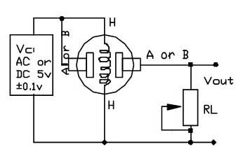

FIG 3.2 INTERFACING CIRCUIT WITH ARDUINO

Since the output of the gas sensors is resistive a resistor has to be connected between the output pin and ground as shown in the adjoining circuit. As you can see no other component is required. There is no specific value for the load resistor. Its value could be from 2kΩ to 47kΩ. Lower the value, the less sensitive. Higher the value less accurate for higher concentrations of gas. This output voltage can directly be given to any ADC or any comparator circuit and accordingly the gas value can be calculated using a lookup table. These sensors can be easily directly connected to micro controllers with internal ADC or with Arduino. 

## 3.4 LIST OF MQ SERIES GAS SENSORS

## MQ2Gas Sensor

#### Sensitive for Methane, Butane, LPG, smoke. This sensor is sensitive to flammable and combustible gasses.

#### MQ3 Gas Sensor

#### Sensitive to Alcohol, Ethanol, smoke

#### MQ4 Gas Sensor

#### Sensitive to Methane and CNG/Natural Gas.

#### MQ5 Gas Sensor

#### Sensitive to Natural gas and LPG.

#### MQ6 Gas Sensor

#### Sensitive to LPG, Natural Gas, coal gas and butane

#### MQ7 Gas Sensor

#### Sensitive for Carbon Monoxide

#### MQ8 Gas Sensor

#### Sensitive for Hydrogen Gas

#### MQ9 Gas Sensor

#### Sensitive for Carbon Monoxide, flammable gasses.

#### MQ131 Gas Sensor

#### Sensitive to Ozone

#### MQ135 Gas Sensor

#### For Air Quality. Sensitive to Benzene, Ammonia, Alcohol and smoke.

#### MQ136 Gas Sensor

#### Sensitive to Hydrogen Sulfide gas.

#### MQ137 Gas Sensor

#### Sensitive to Ammonia.

#### MQ138 Gas Sensor

#### Sensitive to Benzene, Toluene, Alcohol, Acetone, Propane, Formaldehyde gas and Hydrogen gas.

#### 3.5 APPLICATIONS

#### Process control industries

#### Environmental monitoring

#### Boiler control

#### Fire detection

#### Alcohol breath tests

#### Detection of harmful gases in mines

#### Home safety

#### Grading of agro-products like coffee and spices

## 3.6 FEATURES

#### High sensitivity

#### Fast response

#### Wide detection range

#### Stable performance and long life

**CHAPTER 4: EXPERIMENTAL INVESTIGATIONS**

**4.1 Source Code:**

#include <SoftwareSerial.h>

int MQ135 = A3;

SoftwareSerial mySerial(9, 10);

void setup()

{

mySerial.begin(9600); // Setting the baud rate of GSM Module

Serial.begin(9600); // Setting the baud rate of Serial Monitor (Arduino)

pinMode(MQ135, INPUT);

delay(100);

}

void loop()

{

if (Serial.available()>0)

switch(Serial.read())

{

case 's':

SendMessage();

break;

case 'r':

RecieveMessage();

break;

}

if (mySerial.available()>0)

Serial.write(mySerial.read());

}

void SendMessage()

{

float MQ135_volt;

float RS_CO2;

float R0;

float Slope;

float Y_intercept;

float MQ135Value = (analogRead(MQ135));

float Y_Value;

MQ135_volt = MQ135Value * (5.0 / 1023.0);

RS_CO2 = ((5.0 * 32850) / MQ135_volt) - 32850;

R0 = 186987;

Slope = -0.370955166;

Y_intercept = 0.7597917824;

Y_Value = RS_CO2 / R0;

double ppm = pow(10, (log10(Y_Value) - Y_intercept) / Slope);

Serial.println(ppm);

mySerial.println("AT+CMGF=1"); //Sets the GSM Module in Text Mode

delay(1000); // Delay of 1000 milli seconds or 1 second

mySerial.println("AT+CMGS=\"+918897975495\"\r"); // Replace x with mobile number

delay(1000);

if(ppm<1000)

{

mySerial.println("Fresh Air.Feeel Free to breath");

}

else if(ppm>1000&&ppm<2000)

{

mySerial.println("Some what dangerous!!! try to move away");

}

else if(ppm>2000)

{

mySerial.println("Dangerous air. Don't breath even if you die");

}

delay(100);

mySerial.println((char)26);// ASCII code of CTRL+Z

delay(1000);

}

void RecieveMessage()

{

mySerial.println("AT+CNMI=2,2,0,0,0"); // AT Command to receive a live SMS

delay(1000);

}

**CHAPTER 5 : EXPERIMENTAL RESULTS IF ANY**

**5.1 Measurement of CO2 Gas**

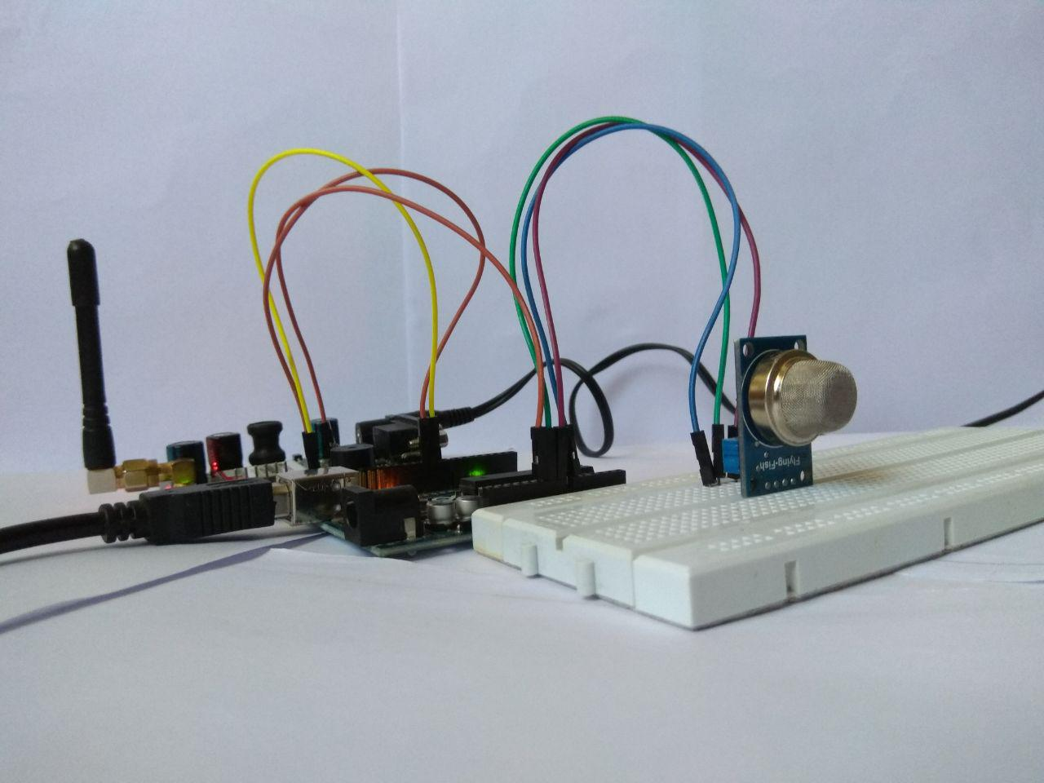

FIG 5.1 MEASURING CO2 GAS

The Obtained PPM value is in Between 800 to 900

**5.2 Measurement of CO2 in a deodorant**

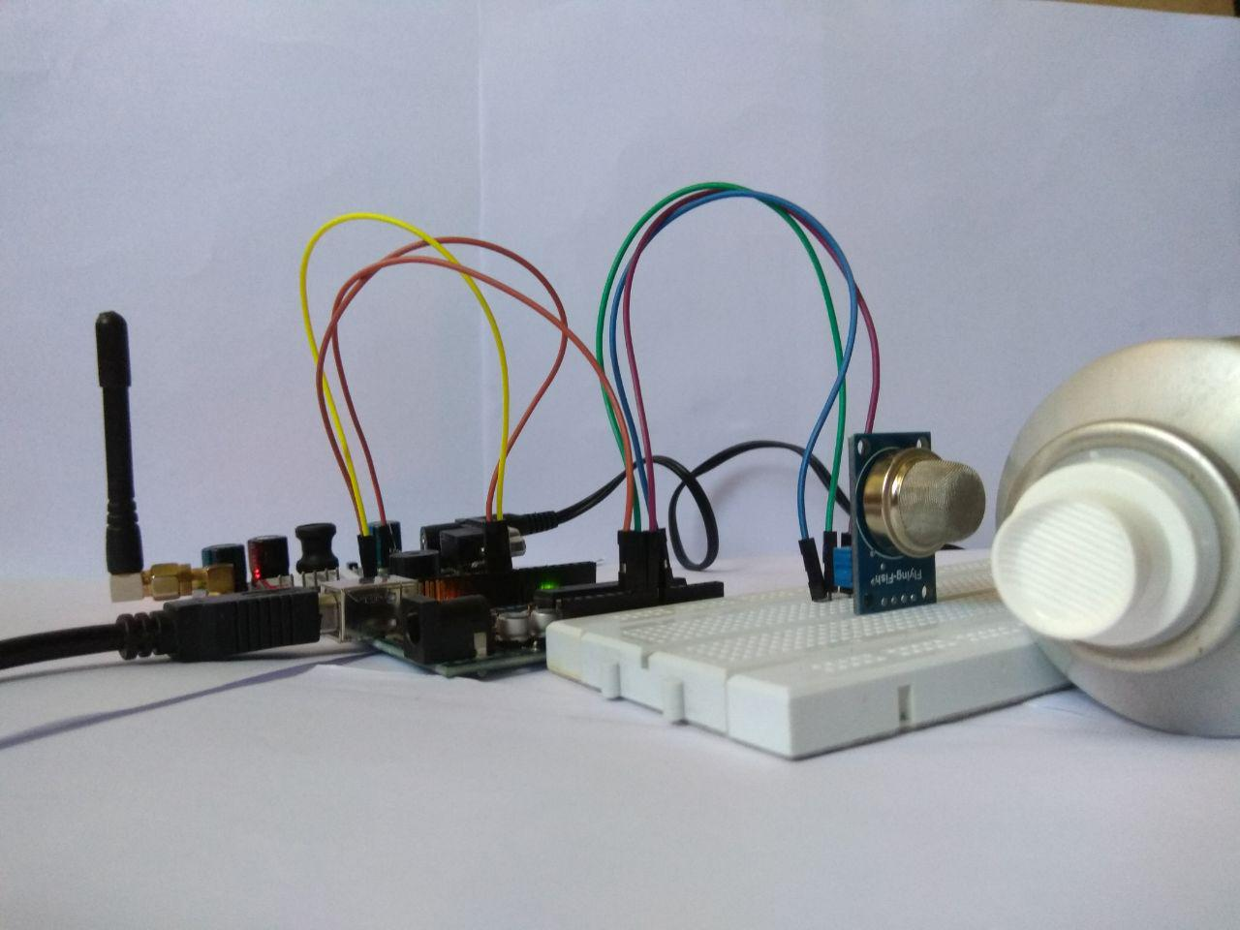

5.2 MEASURING DEO

The Obtained PPM value is in Between 1000 to 1600

**5.3 Measurement of Co2 in a Sandal Wood**

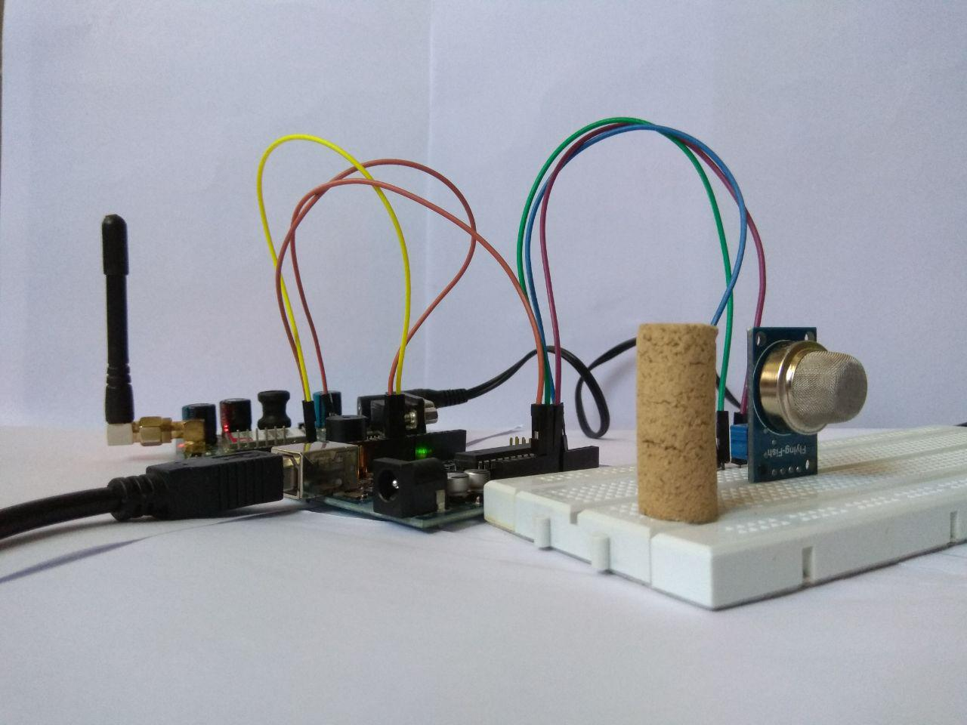

FIG 5.3 MEASURING SANDAL WOOD

The Obtained PPM value is in Between 300 to 500

**5.4 Measurement of co2 From a matchstick**

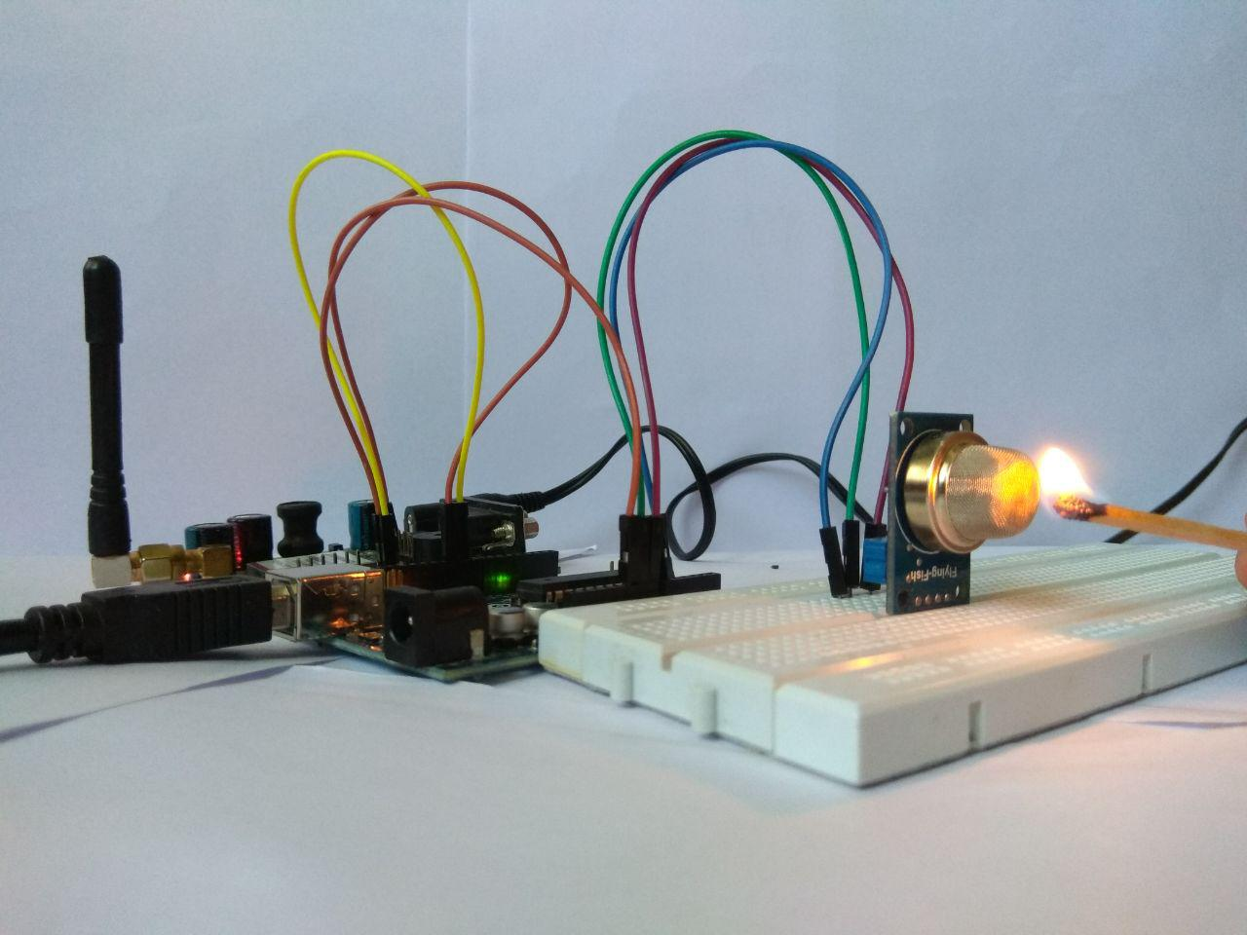

FIG 5.4 MEASURING FIRE

The Obtained PPM value is in Between 00 to 100

**CHAPTER 6: CONCLUSION AND FUTURE SCOPE**

The genuine accomplishment of the sensor organize innovation depends principally on its application in killing a hurtful circumstance or in keeping up a decent one. Planning an effective application is one of the significant difficulties and sensor organize challenges are application subordinate.

Air quality observing is a planned application area which is of specific incentive to our nation. Expansive urban areas with high convergence of industry, concentrated transport systems and high populace thickness are significant wellsprings of air contamination. Foreseeing air quality from different sources by utilizing displaying is exceptionally muddled. Along these lines, air quality models are best utilized for segregated sources or circumstances.

According to the World Bank report cited before, modern contamination in India is on the more disturbing state than modern generation. Thus, controlling and checking air contamination round the clock is a social objective. This investigation demonstrates that WSN could be a valuable component for this twofold undertaking.

The air quality information age through air quality observing system accessible today, includes vast number of checking organizations, individual and gear for inspecting, synthetic

examination and information detailing and so forth. The association of a few offices builds the likelihood of varieties and individual predispositions thinking about the information. Along these lines, the air quality information measurements

accessible today is being perceived to be more demonstrative instead of outright and great.

To complete flawless air contamination models, in particular logical research, air administration and basic leadership, air contamination control, ecological effect and air contamination scenes, ceaseless air contamination observing utilizing sensor organize is the main arrangement. It is required to grow the current observing system. Numerous more on-line stations should be built up to get constant data about the spatial dissemination of contamination and territories of intense contamination.

**CHAPTER 7: REFERENCE**

[1]Peter Osei Boamah,Jacqueline Onumah, ―Air pollution control techniques‖, Global journal on bio-science and biotechnology, Volume1 (2) 2012,pg-124

[2] Shyam Bihari Sharma, Suman Jain, Praveen Khirwadkar, Sunisha Kulkarni, ― The effect of air pollution on environment and human health‖ , Indian Journal of Research in Pharmacy and Biotechnology ,Volume 1(3) May2013,pg-391

[3] Dr Sambrani Vinod N, ―Industrial emission – a case study‖, EXCEL International Journal of Multidisciplinary Management Studies, Volume 3(8), 2013, pg.63-73

[4] Health effects of outdoor air pollution. Committee of the Environmental and Occupational Health Assembly of the American Thoracic Society. American Journal of Respiratory & Critical Care Medicine 1996; 153:3-50.